
🌟 LIMITED LOTS AVAILABLE- GRAB YOUR DREAM LOT IN COVATA, LABASA! 🌟

EXPRESSION OF INTEREST
RESIDENTIAL LOTS FOR SALE AT COVATA, LABASA
EOI No: 2/26

The Housing Authority is excited to announce a call for Expressions of Interest (EOI) for the remaining residential lots in Covata, Labasa.

🏡 Only a few lots left — secure yours now and start building the home you’ve always dreamed of!
This is your chance to invest in a fast-growing residential area before all lots are sold out.

📌 Act fast — opportunities like this don’t last!

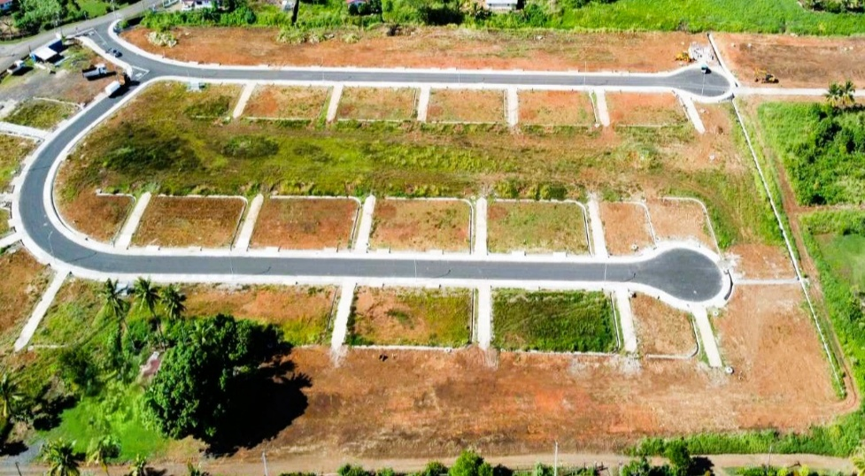

Lot details are provided below:
- 43 Residential Lots available;
- Lot area ranges from approximately 246 sqm to 717 sqm;
- Price of the lot ranges from $43,000 - $92,000; and
- Approximately 97 years of TLTB Lease.

How to Apply
Submitting your Expression of Interest is simple! Access the Customer Online Portal at
https://portal.housing.com.fj/ from the ease of your home through your mobile phone
/laptop or visit our branches to submit your online application.

Eligibility Criteria
- First-time home owner;
- Fijian Citizenship;
- Annual Household income must be $50,024.00 or below;
- Ability to buy the land and build a house;
- Applicant should be above 18 years of age.

Before you start your online application, please ensure scanned copies of the following documents are ready:

- HA Standard Statutory Declaration (available on our website);
- Voter ID or copy of Passport bio data page;
- Latest Payslip stamped by the employer;
- If owning any business or self-employed, please attach Notice of Assessment for the year 2025;
- Full Extract of Birth Certificate and Marriage Certificate;
- TIN letter or FRCS/FNPF joint card; and
- Latest FNPF Statement.

Additional documents must be provided via the application portal, if applicable:

- For married applicant(s) - Both spouses need to provide their personal details as per the above checklist. Should a spouse be unemployed, a proper declaration is required declaring that he/she will need to provide other relevant documents as per the checklist.
- De-facto relationship - Both parties must submit a statutory declaration confirming the duration of the relationship. Please also attach your partner’s details and any other relevant documents as specified in the checklist.
- If Divorced – dissolution of marriage to be attached.
- If widow/widower – death certificate to be attached.
- If Single Parent- Proof of separation (if applicable) and documentation demonstrating that the child’s biological or adoptive mother or father has had sole parental responsibility. For legally separated parents, a mandatory two-year separation period must be completed before applying.
Note:
- The information above is required to determine your Total Household Income and Loan Eligibility.
- For single applicants: Please note that successful applicants will be required to provide a Single Status Certificate from the Ministry of Justice during the due diligence process.

Turn your dream home into a reality with affordable home financing from the Housing Authority to buy your land and build. We will also facilitate the Government’s First Home Ownership Program Grant through the Ministry of Housing.

EOI applications will close on Friday, 6 March 2026, at 4 PM.

Visit any of our Branches located in Valelevu, Lautoka, and Labasa for assistance and further queries. You can also email: CustomerAdvocate@housing.com.fj , call on 9993134, visit our Website: www.housing.com.fj, or follow and like Housing Authority - Fiji on Facebook page.

